

STAGE 4 – ACCESSORIES
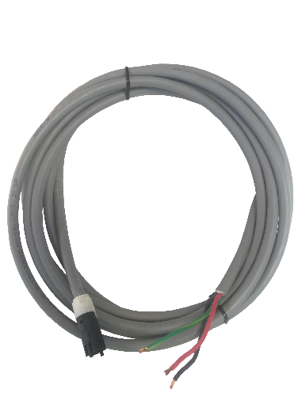

A1.2.3C6.000.4.XXX
Version 4.0 – January 2023

Description:
Connector Lead for Power Circuits
3 Core x 4.0mm²
Low Fire Hazard (XLPE) Cable
Cable Colour: | Grey

Please read instructions before commencing installation and retain for future reference.

Technical Specification:
Material: | Connector:
 | PA66 + 25% GF UL-94 V0 (S/N 704872-1)
 | PA66 unfilled UL-94 V2 (S/N 1573372-1)
Connector Dimensions: | 43.45mm (L) x ø 19mm (W)
Cable Insulation: | HFS-90-TP Sheath (GY)
Cable Rating: | 450/750V to AS/NZS 5000.2
Minimum Bending Radius: | Fixed: 70mm
 | During Installation: 100mm
Overall Cable Diameter: | 11.5mm
Maximum Operating Temperature: | 90°C
Enclosure Class: | IP20
Rated Current (A): | 25A
Power Outputs: | 4 Pole (3 Wire)
Rated Voltage (V): | 240V
Frequency (Hz): | 50Hz
Wire Size (mm²) | 4.0mm²
Weight: | 236g (based on 1m)
Wiring & Test Standard: | AS/NZS 3000
Connector Coupler Standard: | AS/NZS 61535:2011

